**DS Concepts**

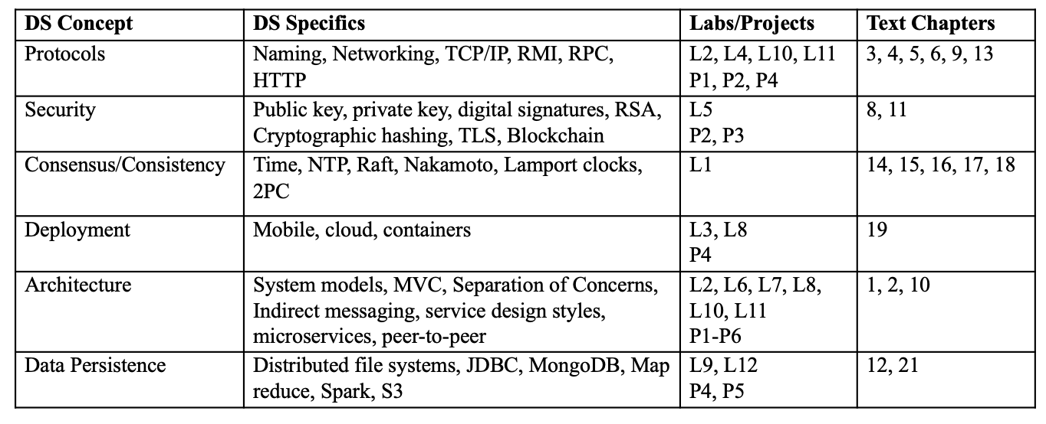

**Week 1**

**Lec 1-1 Raft and Blockchain Consensus**

Two approaches to implementing distributed consensus: Raft consensus, Nakamoto consensus (Bitcoin)

1. **Raft**
   1. **Security threat**

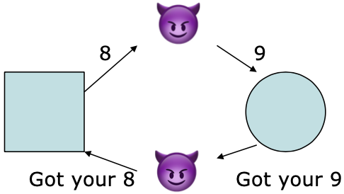

Raft is a protocol共识算法 focusing on reaching consensus (in the presence of node or network failure).

//Raft不处理这个threat

Quiz: How could signatures help?

* 1. **Reliability in the face of node failure - Suppose the server crashes after responding:**

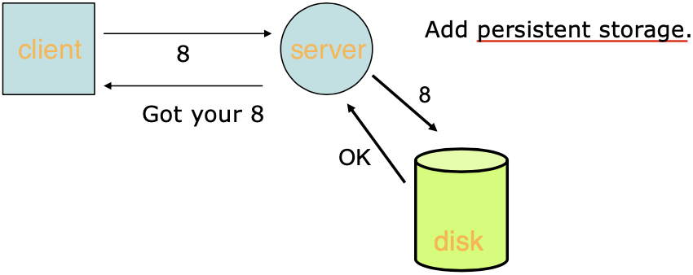

* 1. **Improving reliability**

要成为leader需要50%以上的vote

1. **Nakamoto consensus**

Unlike Raft, Nakamoto Consensus is designed to be Byzantine Fault Tolerant

* 1. **New transactions are broadcast to all nodes.**

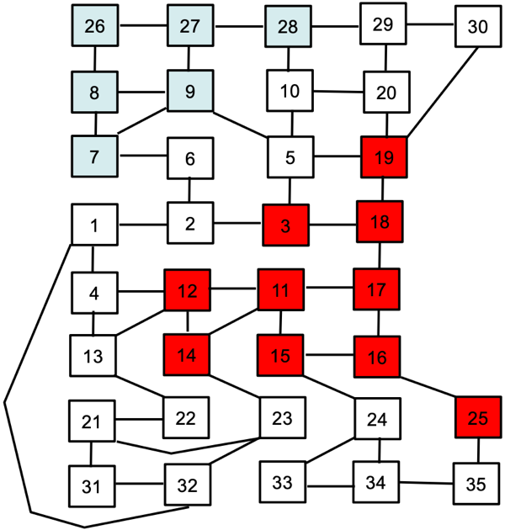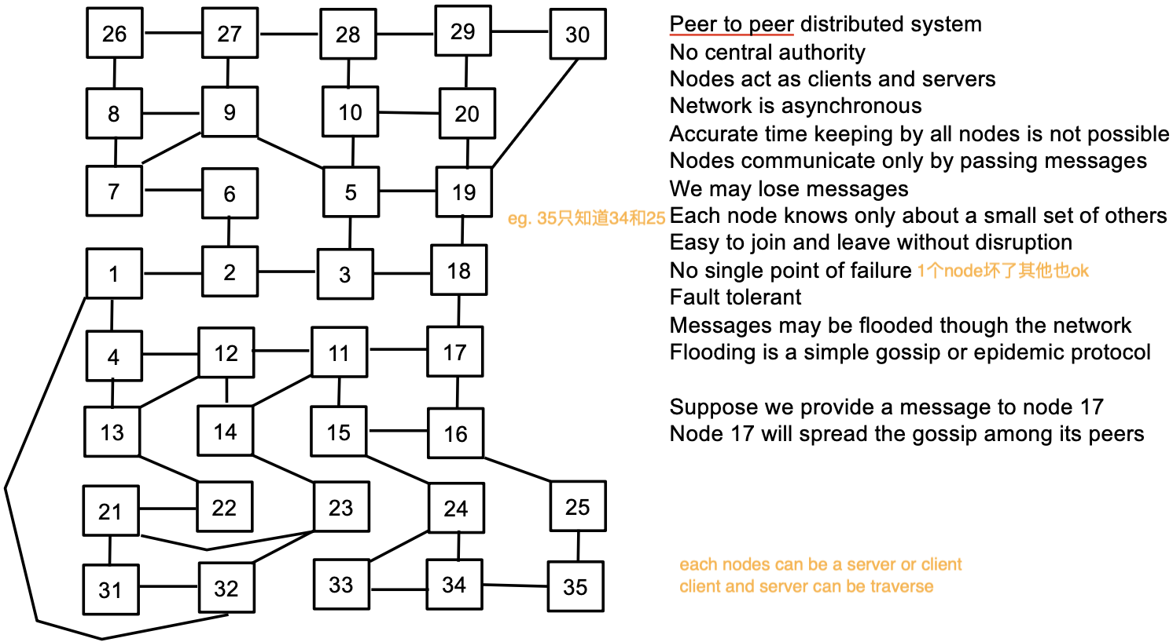

* 1. **Each node collects new transactions into a block.**

Node的3种state：

Leader // leader是有任期term的

Follower //所有node从follower开始

Candidate // raft任何时刻，每一个服务器都处于这三个状态中的其中一个

* Leader Election1领导者选举：Candidate获得其他system投票变成leader的过程

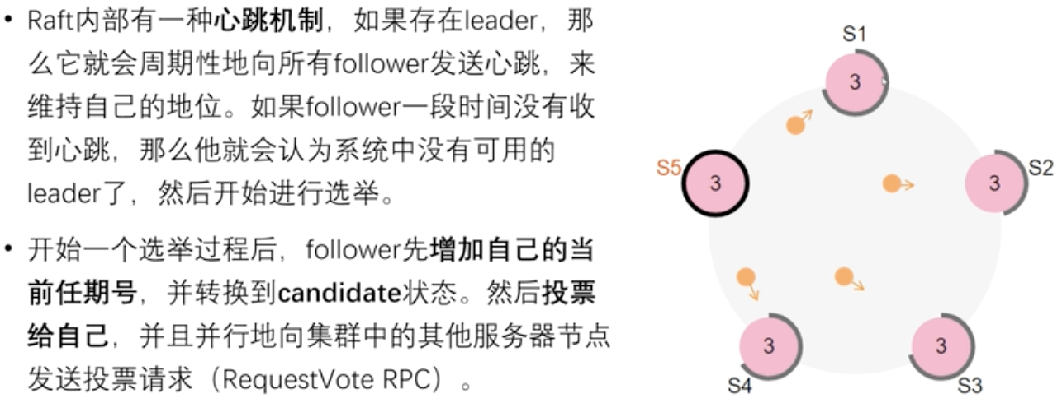

* Log Replication2日志复制：leader获得信息然后给follower然后wait for response最后commit的过程 - Once we have a leader elected we need to replicate all changes to our system to all nodes.
* Election timeout: the amount of time a follower waits until becoming a candidate. // random

The leader begins sending out *Append Entries* messages to its followers.

These messages are sent in intervals specified by the heartbeat timeout.

Followers then respond to each *Append Entries* message.

* 1. **Each node works on finding a difficult proof-of-work for its block. 工作量证明**
  2. **When a node finds a proof-of-work, it broadcasts the block to all nodes.**

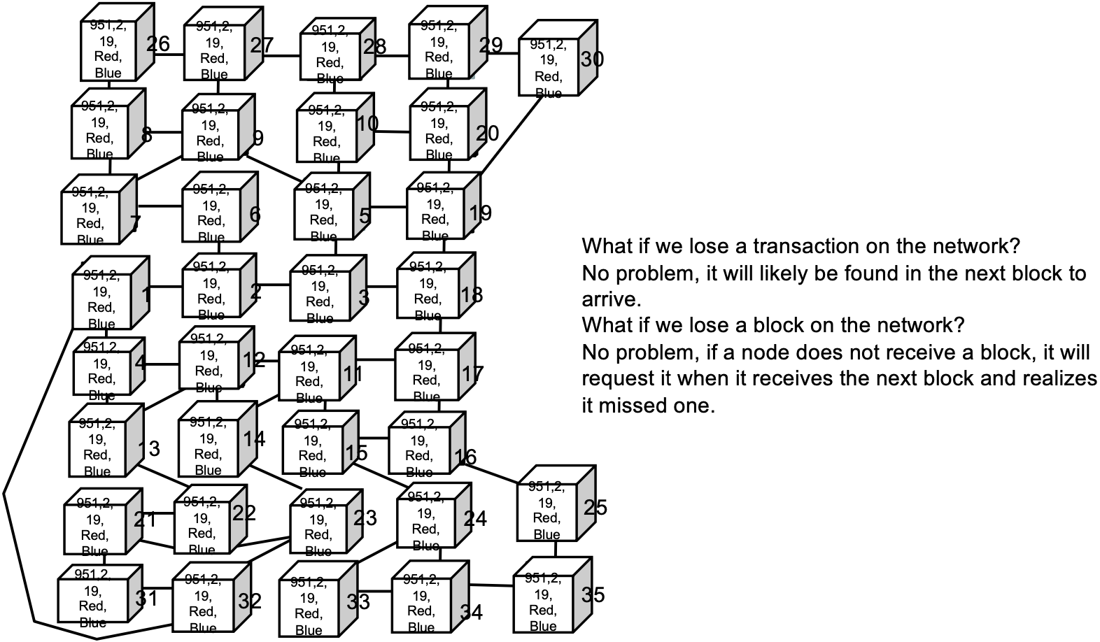

* 1. **Nodes accept the block only if all transactions in it are valid and not already spent.**
  2. **Nodes express their acceptance of the block by working on creating the next block in the chain, using the hash of the accepted block as the previous hash.**

**// Quiz: PPT1 P60**

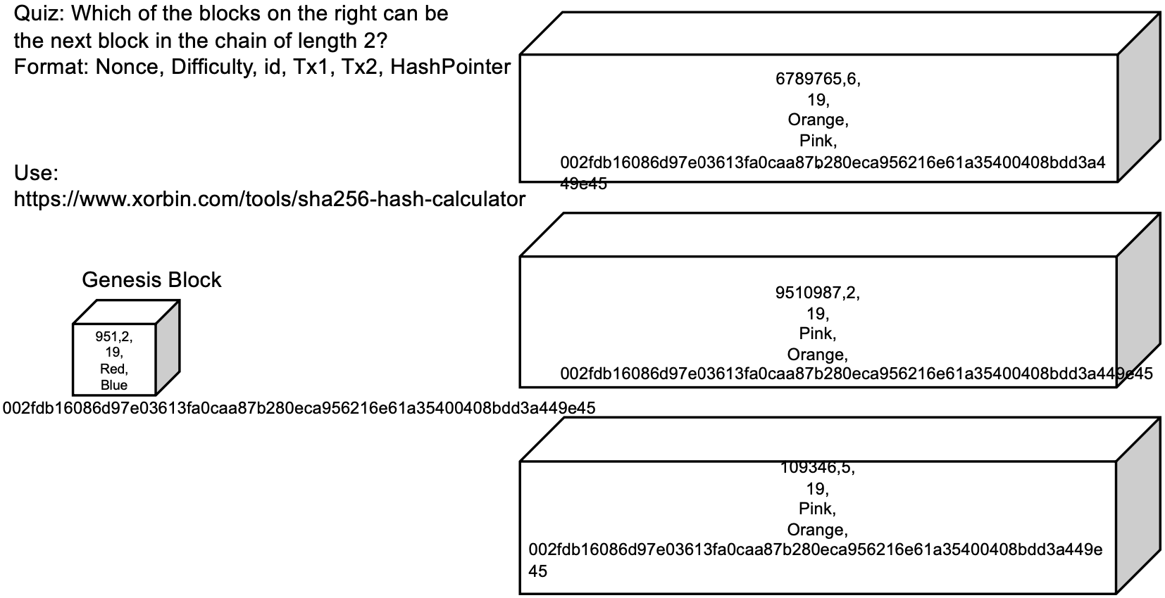



[Use the SHA256 calculator that you used before](https://emn178.github.io/online-tools/sha256.html) to answer the quiz question on the slides.

Note: There are no newlines or return characters in the correct answer.

109346,5,19,Pink,Orange,002fdb16086d97e03613fa0caa87b280eca956216e61a35400408bdd3a449e45

// 通常difficulty是几 SHA-256就要以几个0开始，只有最后这一串满足diff = 哈希值最左边0的数量

**Lab 1**

1. Explain why the request is not committed on the peers (with dark edges surrounding the term) until after the leader visits twice - once with the request and then a follow up confirmation.

None of the nodes commit the request until a majority of nodes have voted to commit the request. So, simply receiving the request and responding with a vote is not enough. The peer must wait until the server counts the votes and affirms that a majority says to commit.

在大多数节点投票决定commit请求之前，所有节点都不会commit请求。因此，仅仅接收请求并进行投票是不够的。peer必须等待，直到服务器计算选票并确认大部分都投票。

1. Working with a fresh copy of the [Raft simulator](https://raft.github.io/raftscope/index.html), do the following:

* a. Send two requests from the leader to all followers.
* b. Stop one of the followers.
* c. Send four requests from the leader to the remaining followers.
* d. Resume the stopped follower.

Explain what happened and why.

The additional four requests were not replicated to the stopped follower. But, when the follower came back online, the algorithm brought the follower up to date with the correct replica.

另外四个请求没有复制到停的follower。但当follower重新上线时，会把落下的请求同步给它

1. Working with a fresh copy of the [Raft simulator](https://raft.github.io/raftscope/index.html), do the following:

* a. Wait until a single leader is established.
* b. Stop three of the four followers.
* c. Send three requests from the leader, one after the other.

Explain what happened and why. Also, explain what happens if the three followers are started back up.

The three request are being held by two machine as tentative and not committed. There is no majority support for these requests. When the three followers are resumed, they are told of the three requests and the entire cluster comes into consensus.

这三个请求被两台机器暂时保留，没有提交。这些要求没有得到大多数人的支持。当三个追随者重新开始时，他们被告知这三个请求，整个集群达成共识。

1. 上面那个Quiz: Which of the blocks on the right can be the next block in the chain of length 2

--- difficulty = 哈希值左边0个数

1. Think about the following questions:
   1. What is the role of the followers in the Raft protocol?
   2. What are some limitations of the Raft protocol?
   3. In the Raft protocol, the followers play an important role in achieving consensus. The followers receive log entries from the leader and replicate them to their local logs. They also respond to the leader’s heartbeat messages to confirm their availability and to reset their election timeout. If a follower does not receive a heartbeat message from the leader within a certain period of time, it assumes that the leader has failed and changes its status to candidate, starting a new election process. During the election process, the candidate requests votes from other servers in the cluster. If a candidate receives votes from a majority of servers, it becomes the new leader.

In summary, the role of the followers in the Raft protocol is to replicate log entries from the leader, respond to heartbeat messages, and participate in leader elections.

* 1. The Raft protocol has some limitations, including:
  + Raft is strictly a single leader protocol. Too much traffic can choke the system.
  + Raft is not a Byzantine fault-tolerant (BFT) algorithm: the nodes trust the elected leader.
  + Raft has a restriction in which nodes with the latest submitted logs are only eligible to be leaders. 只有具有最新提交日志的节点才有资格成为leader（确保了新当选的leader总是拥有集群中所有节点的最新数据）

These limitations can affect the performance and reliability of the Raft protocol in certain situations.

**Week 2**

// Lab only

**Lab 2**

Interesting picture里：

1. [In the model class, study how the fetch( ) method works.](https://github.com/CMU-Heinz-95702/Lab2-InterestingPicture#4-in-the-model-class-study-how-the-fetch--method-works)
   1. Why is a while loop used - what is the body of the loop doing?
   2. Put a breakpoint in the loop and examine the value of str with each iteration. What format is the str data?

原理：in.readLine()每次从输入流中读取一行内容，并将其添加到response字符串中，直到没有更多的行可以读取

while ((str = in.readLine()) != null) {

response += str;

}

str is one line of text readLine() strips newline characters

1. [Add an Easter Egg in the web app.](https://github.com/CMU-Heinz-95702/Lab2-InterestingPicture#6-add-an-easter-egg-in-the-web-app)

In the result.jsp file, if the search word from Flickr is "Andy", then do not display the Flickr image. Instead, display the following image of Andrew Carnegie ten times. //You *must* use an embedded Java loop

Note: this is not a good MVC separation of concerns, it's just an exercise in writing JSP. You should think about why that is!

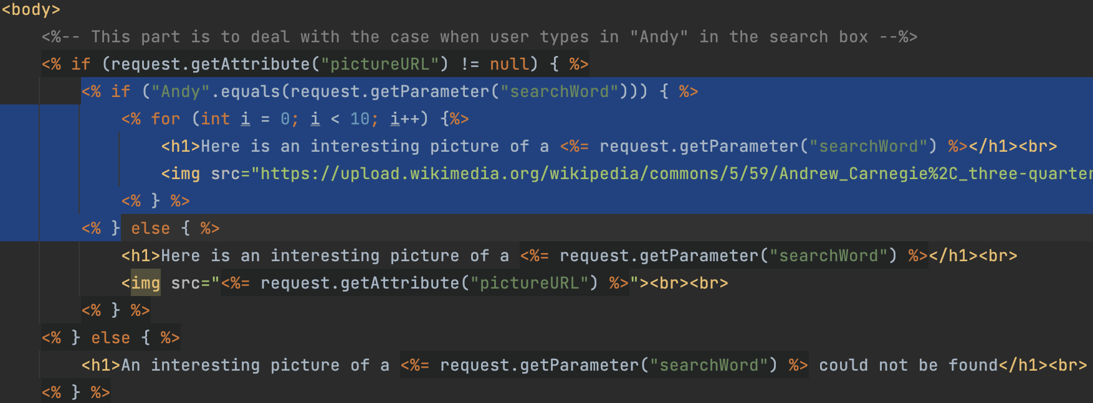

**Week 3 Server-Side Programming**

**Lec 2-1 HTTP &** **Server-Side Programming**

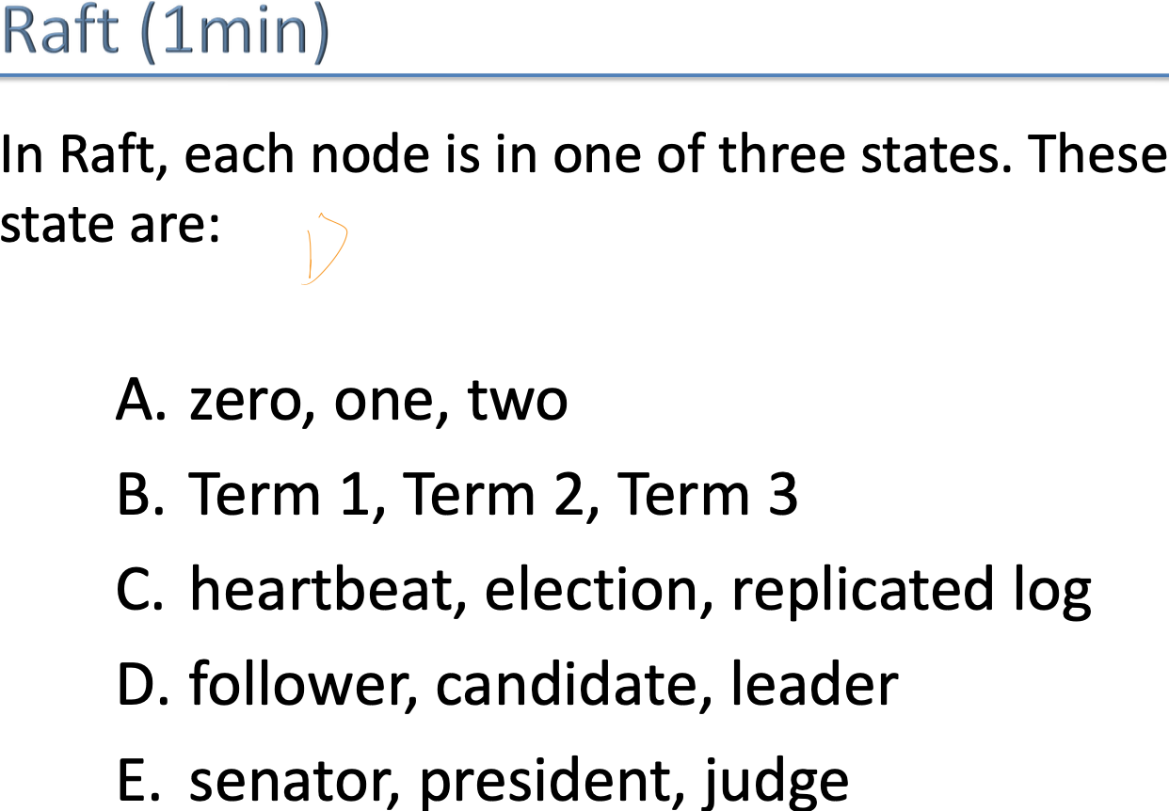 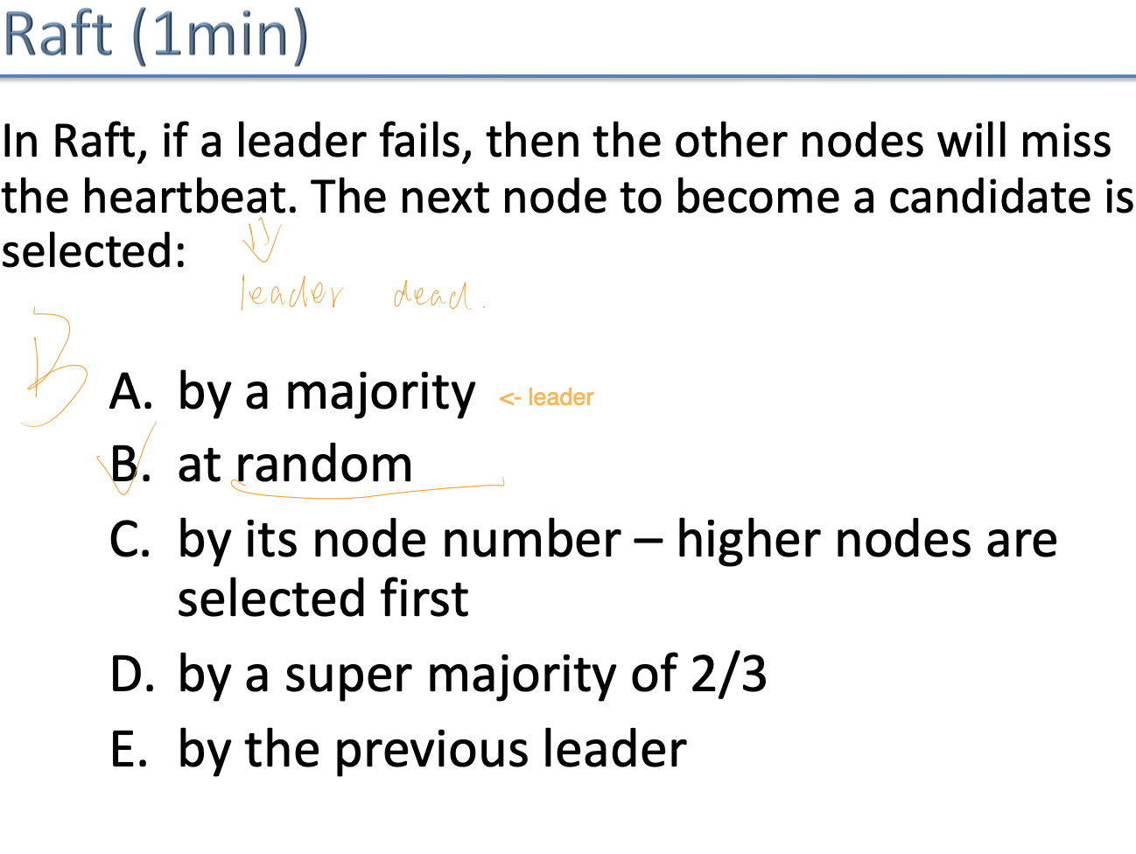

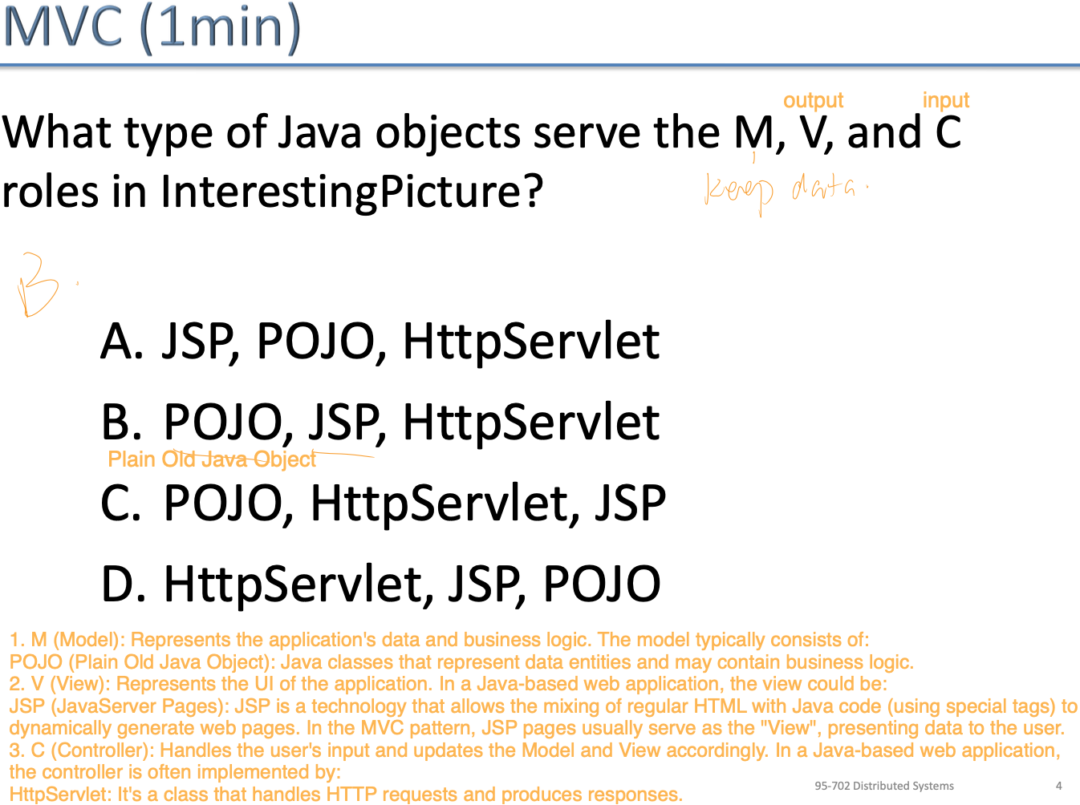 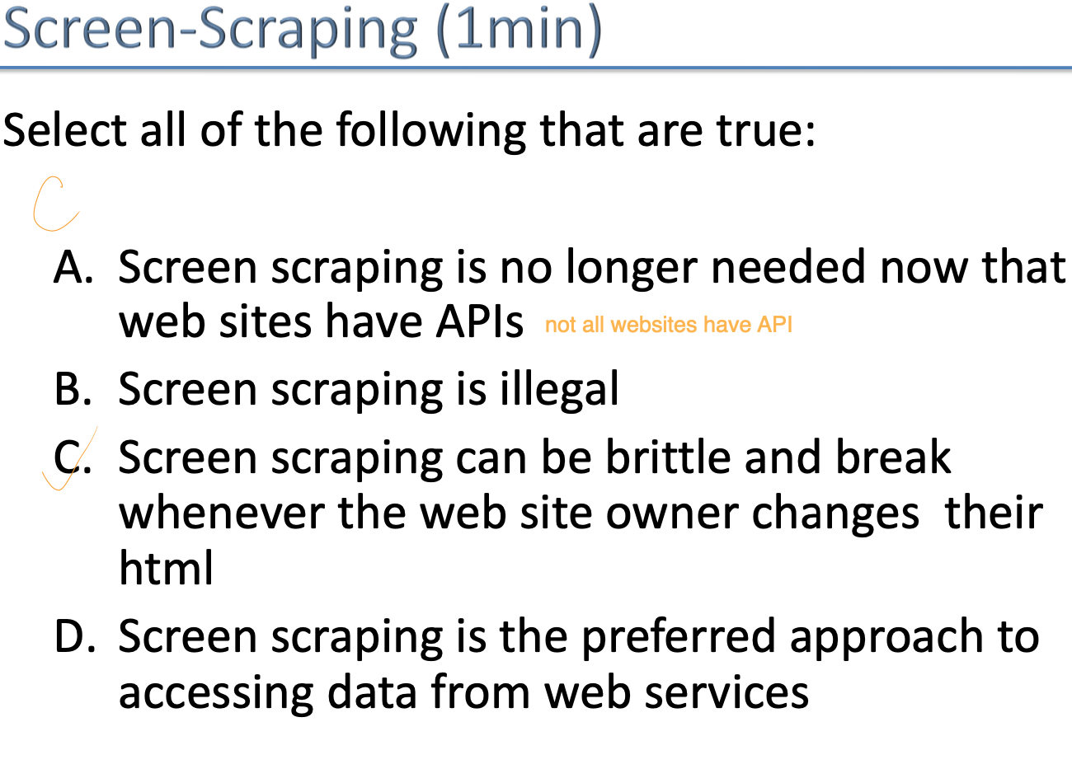

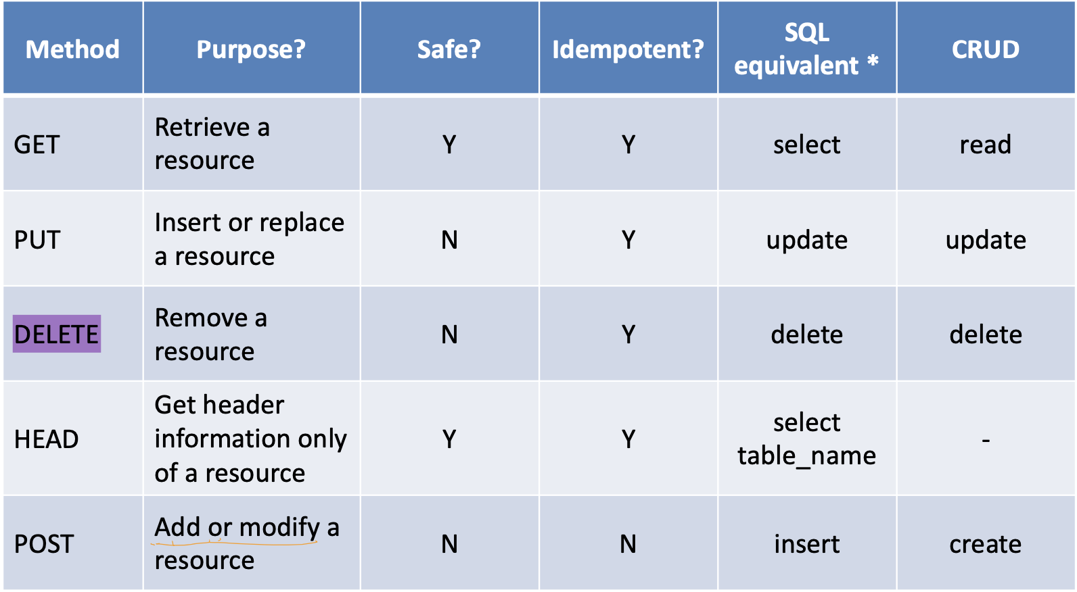

**HTTP/2 what are the key differences from HTTP/1.x**

At a high level, HTTP/2:

· is binary, instead of textual

· is fully multiplexed, instead of ordered and blocking是完全多路复用，而不是有序和阻塞

· can therefore use one connection for parallelism可以使用一个连接来实现并行性

· uses header compression to reduce overhead使用报头压缩来减少开销

· allows servers to “push” responses proactively into client caches允许服务器主动将响应“推送”到客户端缓存中

extend (inherit from) HttpServlet

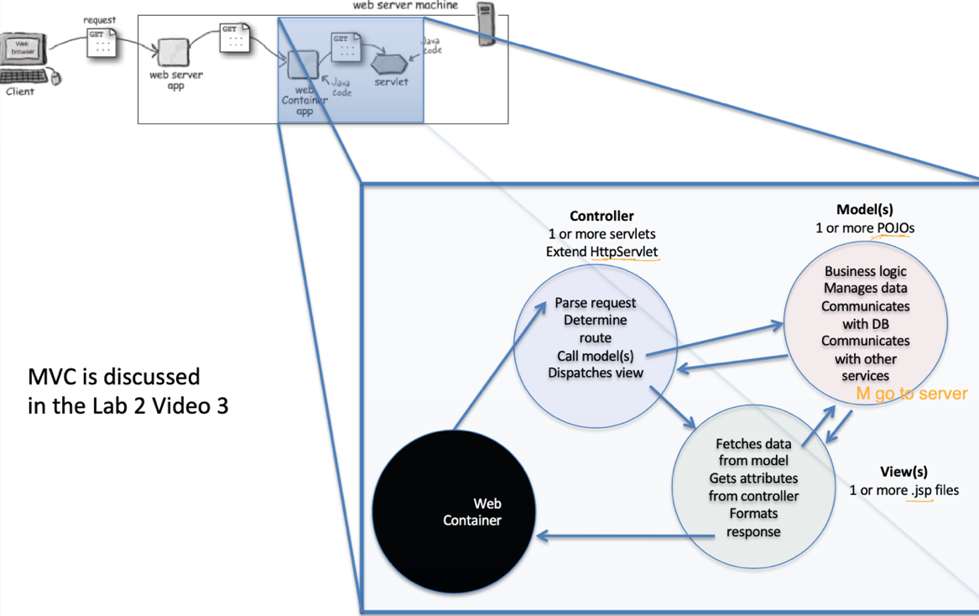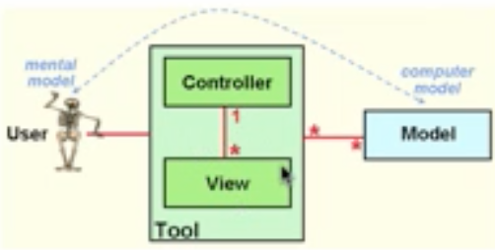

**Lab 3**

1. **(intro) Read a little (here and/or on the web) about Docker containers**

***Docker*** is a technology for creating containerized applications - that is, your application runs inside a portable container that has all the elements needed to run that application. "Container" means a **process** (running program) that executes on a machine. "Portable" means the container can be executed on your laptop or moved to another machine - like a cloud server. The container is isolated from other processes on the host machine, so if it crashes, it shouldn't take any other processes down. There are a few issues with isolation, though - for example, the ports that a regular process can access via sockets must be mapped from the container's internal (virtual) ports to the host's actual ports. Systems can be composed of multiple containers that typically use some other technology (like [Kubernetes](https://kubernetes.io/)) to talk to each other (instead of low level port access). See Docker's [documentation](https://docs.docker.com/) for more details. At the end of the lab, there's a reading assignment about Docker.

A Docker **image** is an executable file created from a Dockerfile containing all the Docker commands needed to make the image plus a self-contained application. For example, a Web servlet must be packaged as a [war](https://en.wikipedia.org/wiki/WAR_(file_format)#:~:text=In%20software%20engineering%2C%20a%20WAR,that%20together%20constitute%20a%20web) file for use here. When the image is created, it will have an assigned UUID (unique identifier) and image name.

The Docker commands used in the lab are all preceded by "docker"; they are case-sensitive; and when you create the Dockerfile, it ***must*** be in Linux-style format: no ".txt" on the end, and Unix line endings (see below for details)

1. (Part 1) Install Docker Desktop and run InterestingPicture inside a container on your laptop. That's the 1/4 point checkpoint.
2. (Part 2) Create a Codespaces account in the Cloud and run your Docker container there. That's the 3/4 point full lab.
3. Cloud and Containers Concepts - This is not part of the lab credit, but it will be covered on the exam.

* Read this article:

<https://www.infoworld.com/article/3077875/linux/containers-101-docker-fundamentals.html>

* Read "A Descriptive Literature Review and Classification of Cloud Computing Research", journal pages 36 through 39 (PDF pages 3 through 6).

<http://aisel.aisnet.org/cgi/viewcontent.cgi?article=3672&context=cais>

// You must be on campus, or using the campus VPN, to view this article.

* Answer these two questions. This is not part of getting credit, but you need to know this.

i) Is a service like AWS an example of IaaS, Paas, or SaaS?

ii) What property makes Docker containers suitable for version control? (If you don't know what version control is, see this: <https://en.wikipedia.org/wiki/Version_control>)

By requiring explicit commits that generate new images, Docker forces you to do version control. You can keep track of successive versions of an image; rolling back to a previous image (therefore to a previous system component) is entirely possible, as previous images are kept and never modified.

**IaaS (Infrastructure as a Service)**: This provides virtualized computing resources over the internet. Examples from AWS include:

**PaaS (Platform as a Service)**: This provides a platform that allows customers to develop, run, and manage applications without dealing with the infrastructure associated with developing and launching an app.

**SaaS (Software as a Service)**: This provides software over the internet on a subscription basis.

**Week 4 Networking**

**Lec 3 Networking**

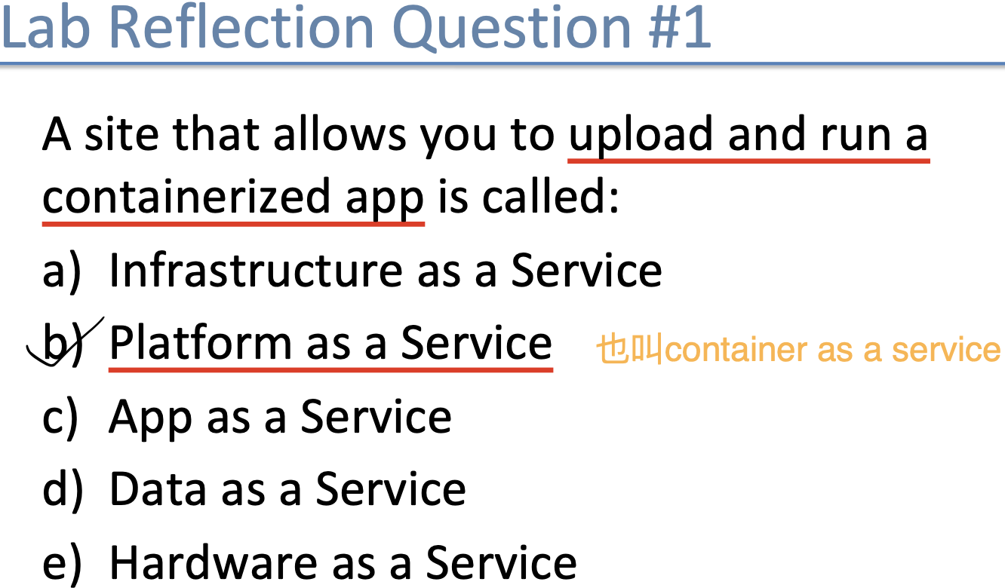 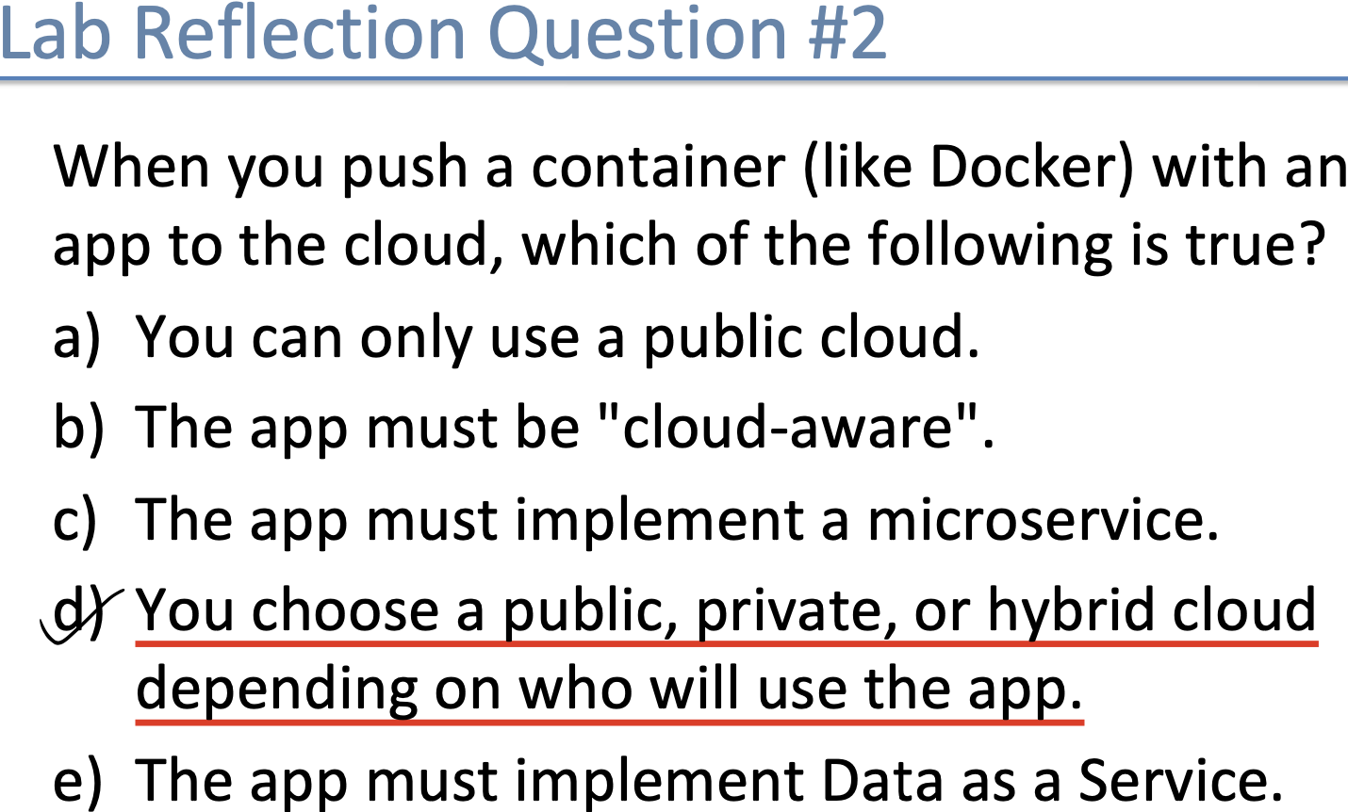

1. **Terminology** 
   1. **Host主机**

• Desktop computers

• Laptops  
• Printers  
• Nest thermostats

• Intelligent light switches  
• Phillips Hue lights  
• Other IOT Devices  
• I.e. anything with a network connection

* 1. **Routers 路由器**

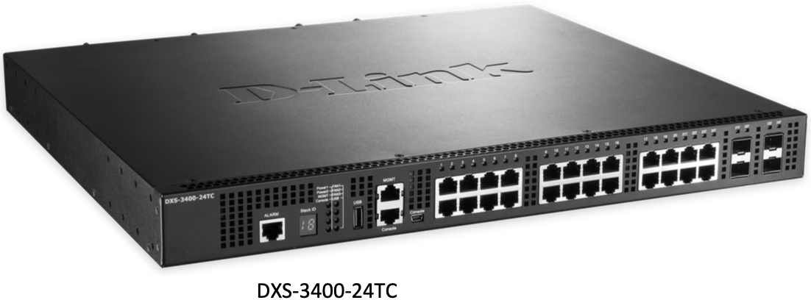 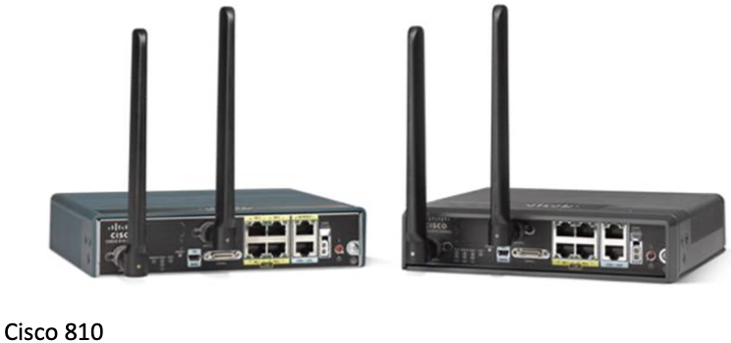

* 1. **Internetwork**

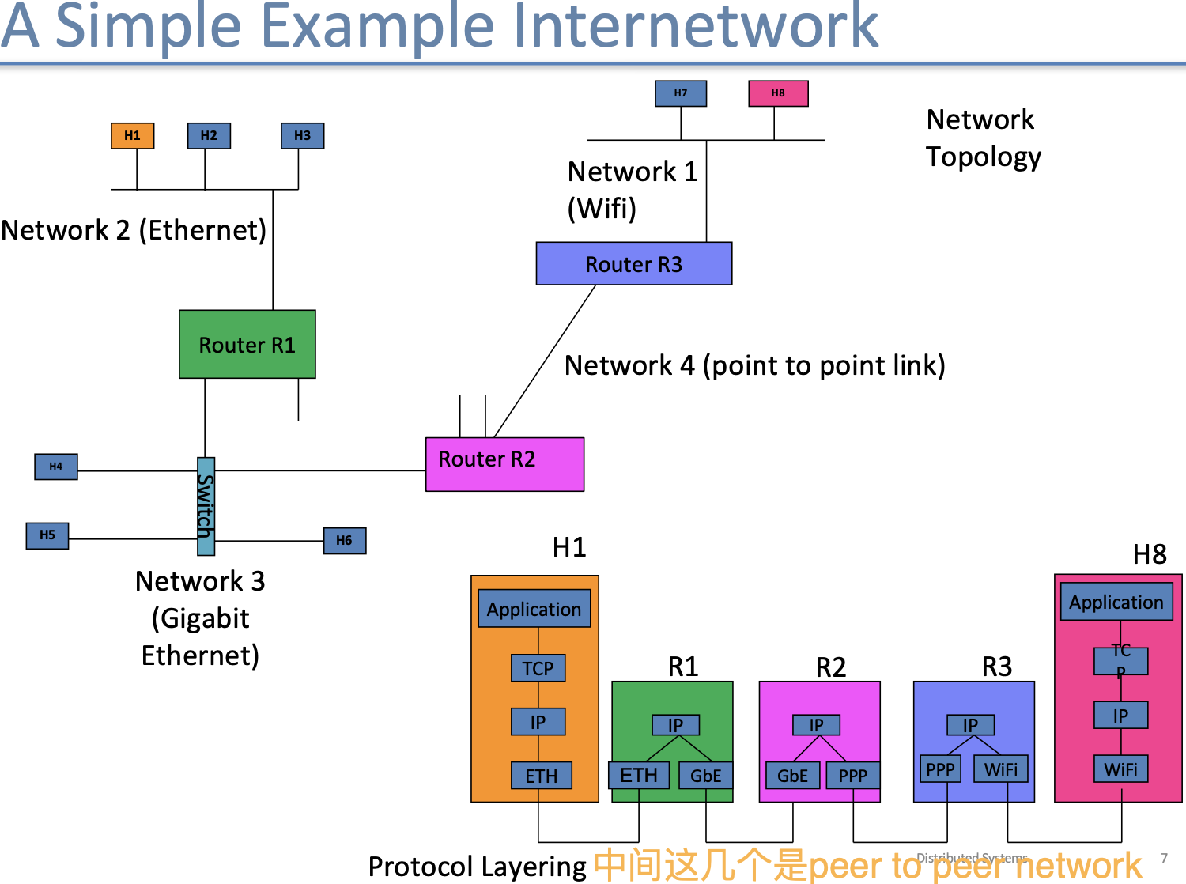

* 1. **Layering & Encapsulation**

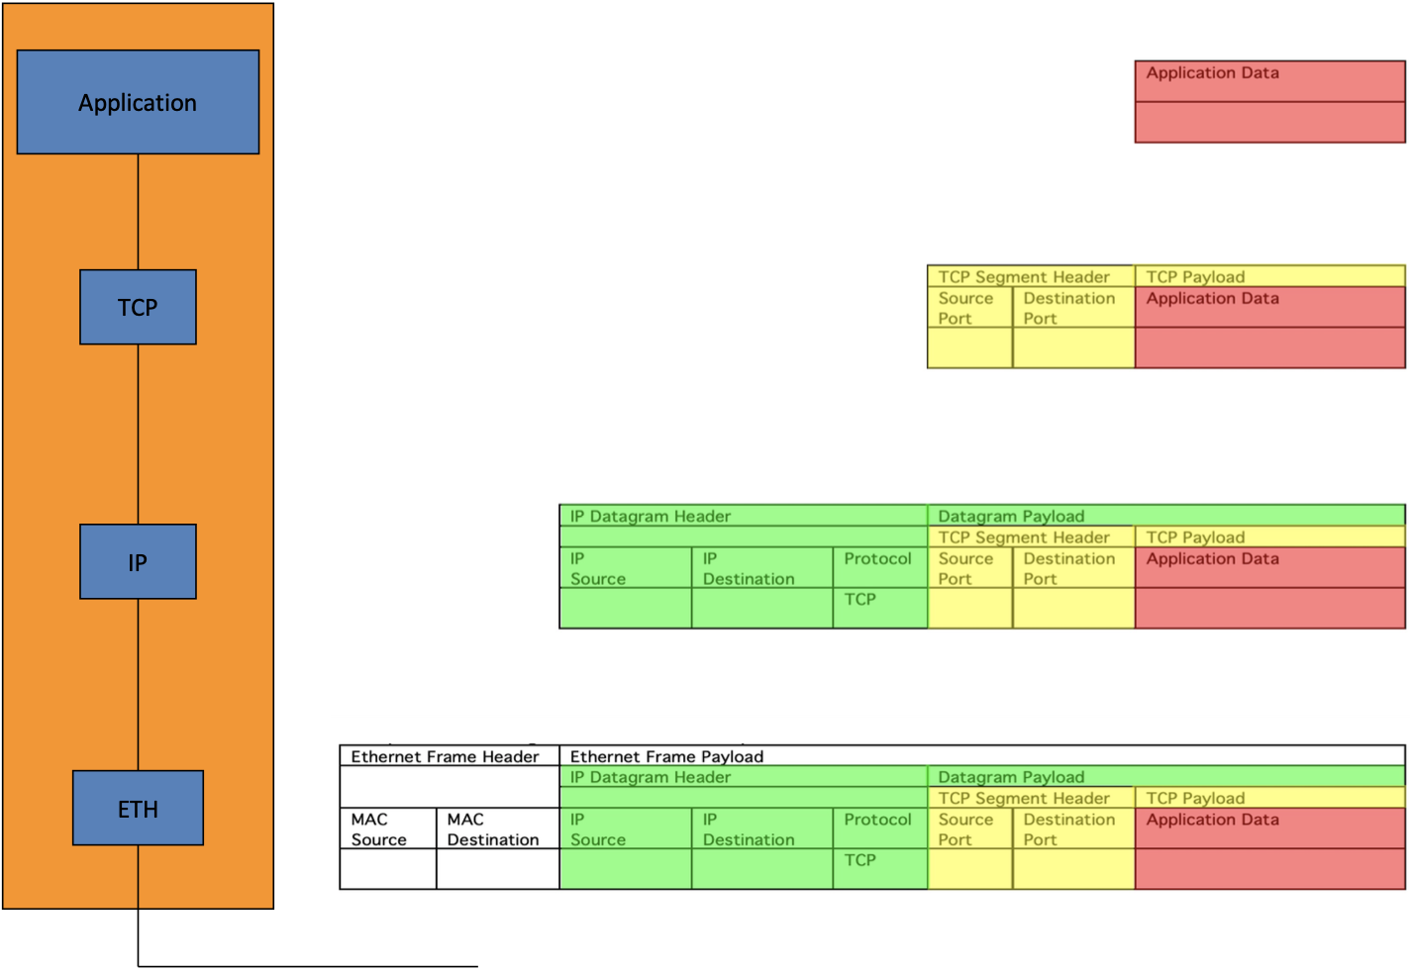

Application, Transport, internet, link layer

Each layer provides an abstraction

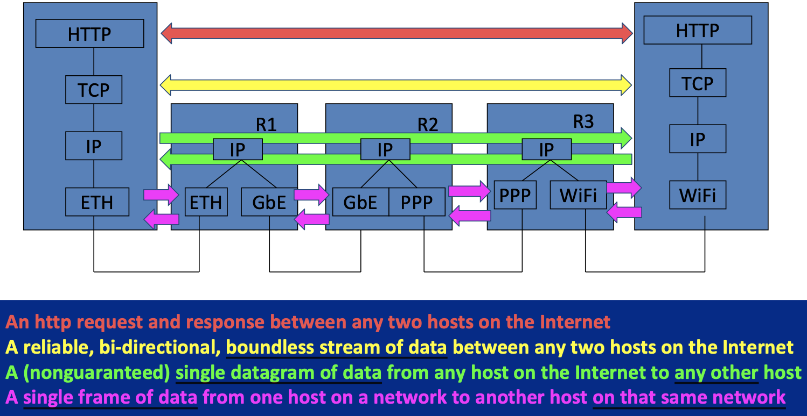

* 1. **Understanding IP Addressing**

Given an IP address and a Subnet mask, you should know: // EXAM!! (不能看Google sheet)

–  What the Network address is

–  What the Host number is

–  Whether two IP addresses are on the same or different networks

EX:

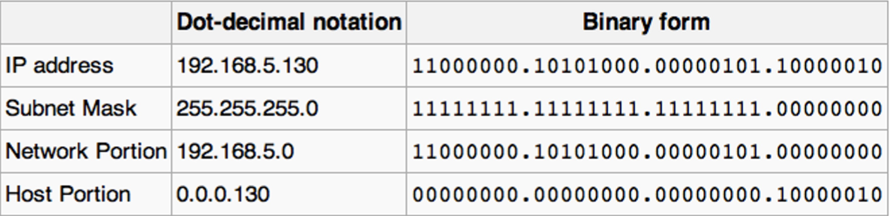

* + 1. **Network Address 网络地址**

IP地址和子网掩码按位与

IP地址： 192.168.1.10 = 11000000.10101000.00000001.00001010

子网掩码： 255.255.255.0 = 11111111.11111111.11111111.00000000

-----------------------------------------------------------------------------------------------------------------------------

网络地址： 11000000.10101000.00000001.00000000 = 192.168.1.0

// 按位与：两个都是1才是1

* + 1. **Host Number 主机号**

子网掩码按位取反，结果和IP地址按位与

IP地址： 192.168.1.10 = 11000000.10101000.00000001.00001010

子网掩码取反： 0.0.0.255 = 00000000.00000000.00000000.11111111

-------------------------------------------------------------------------------------------------------------------------

主机号： 00000000.00000000.00000000.00001010 = 0.0.0.10

* + 1. **算这俩IP地址的网络地址，如果相同，那么就在同一个网络；否则不在**
  1. **Assigning IP addresses**

How is your laptop’s IP address assigned?

· Static – from a network administrator

· Dynamic – Dynamic Host Configuration Protocol

// IPv4 Addresses are 32 bits

//

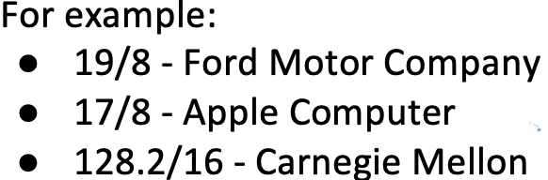 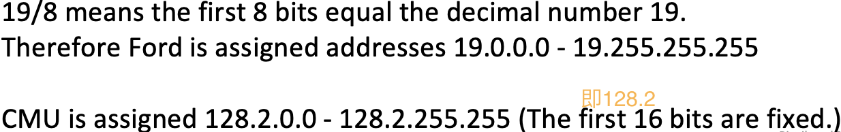

* 1. **DHCP Negotiation**

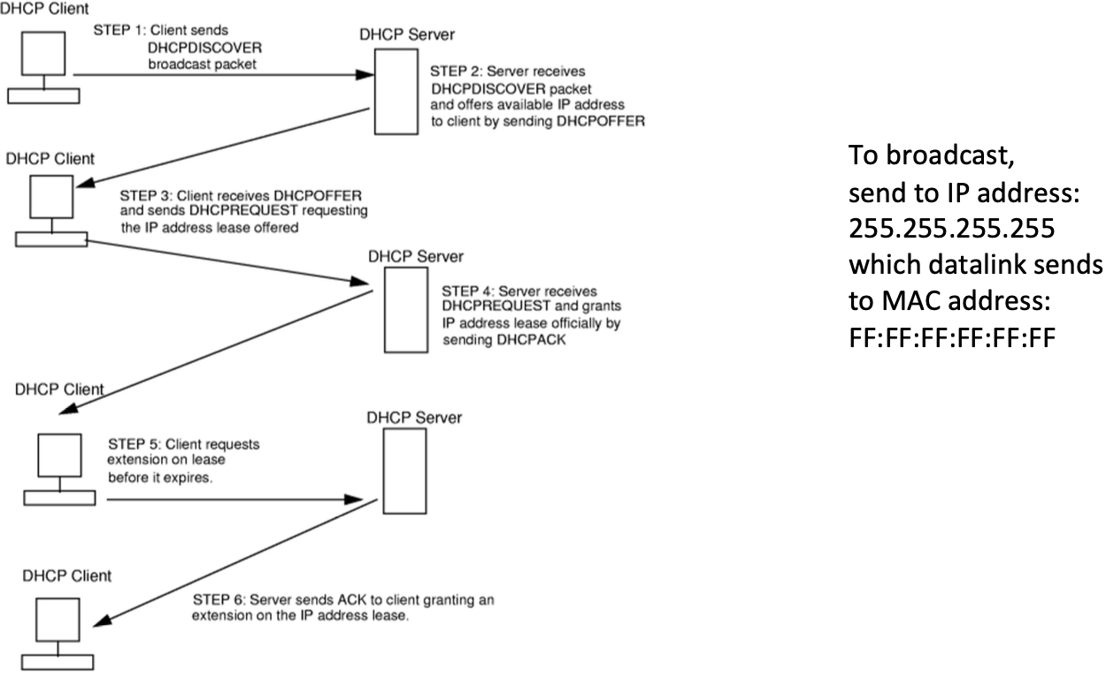

**The DHCP “Offer” contains:**

• IP Address being offered to the client  
• Subnet mask for the local network  
• Gateway IP (default router out of this network)  
• Domain Name System (IP address of DNS server)

• Lease duration

1. **Internet Addressing Practice Sheet**

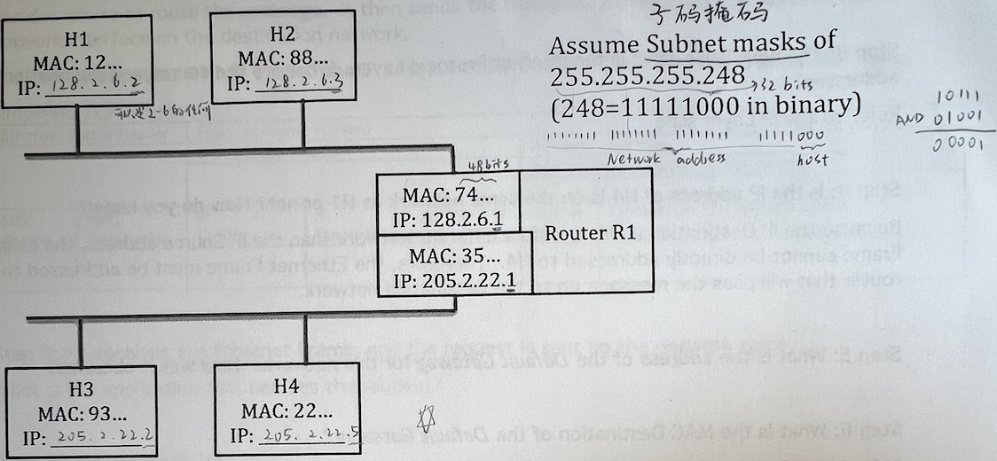

* 1. **What are valid IP addresses for H1 - H4?**

IP addresses for H1 - H4 can be assigned from the host addresses

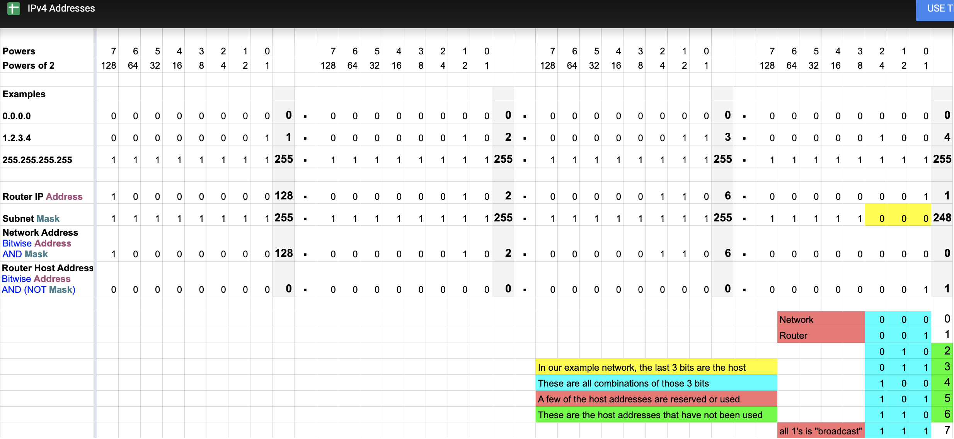

* 1. **How is an HTTP request passed via TCP/IP from H1 to H4?**

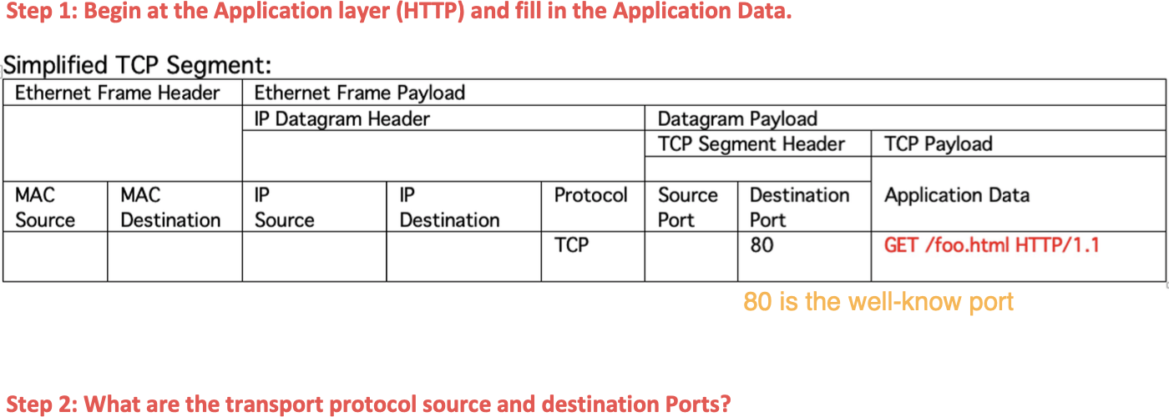

**Transport Level Protocols**

* Two common transport level protocols

– UDP

– TCP

* Both facilitate communication:

– From a port on one host

– To a port on another host

* The communication metaphor between two ports is called a “socket”.
* E.g.  
  – A UDP socket

– from 128.2.25.11 port 5443  
– to 204.100.2.1 port 4568  
– Commonly noted 204.100.2.1:4568

* E.g.  
  – A TCP socket

– Between 128.2.25.22:4567

– And 204.100.2.2:5432

**Transport (TCP/UDP) Addressing - Port**

* Port is a transport-layer software construct
* Port is a 16 bit integer
* 65,536 different Ports an application can communicate on
* Or, 65,536 different applications selected by port number
* Official ports are assigned by IANA (Internet Assigned Numbers Authority)

**Transport Layer Protocols - TCP** Transmission Control Protocol

* Provides a socket & port abstraction across hosts
* Reliable, bi-directional, boundless stream of data
* Not fire and forget. Demands acknowledgements! // every bit is exactly right

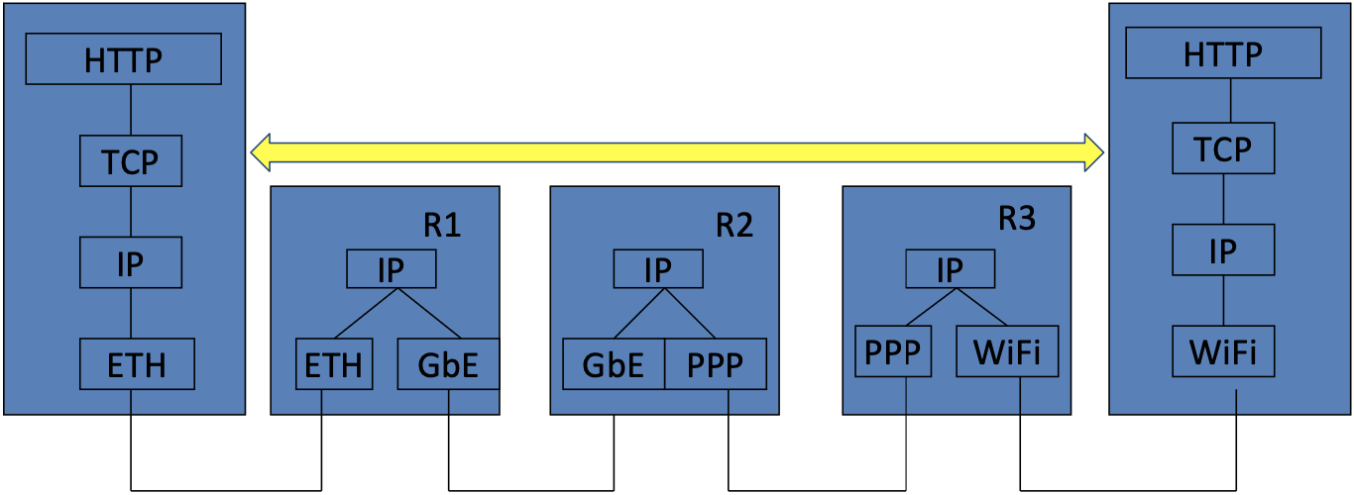

**Transport Layer Protocols - UDP** User Datagram Protocol

* Also provides socket & port abstraction
* A single datagram that fits within an IP datagram
* Not reliable: Fire and forget messaging pattern
* Reliability can be added at the application layer

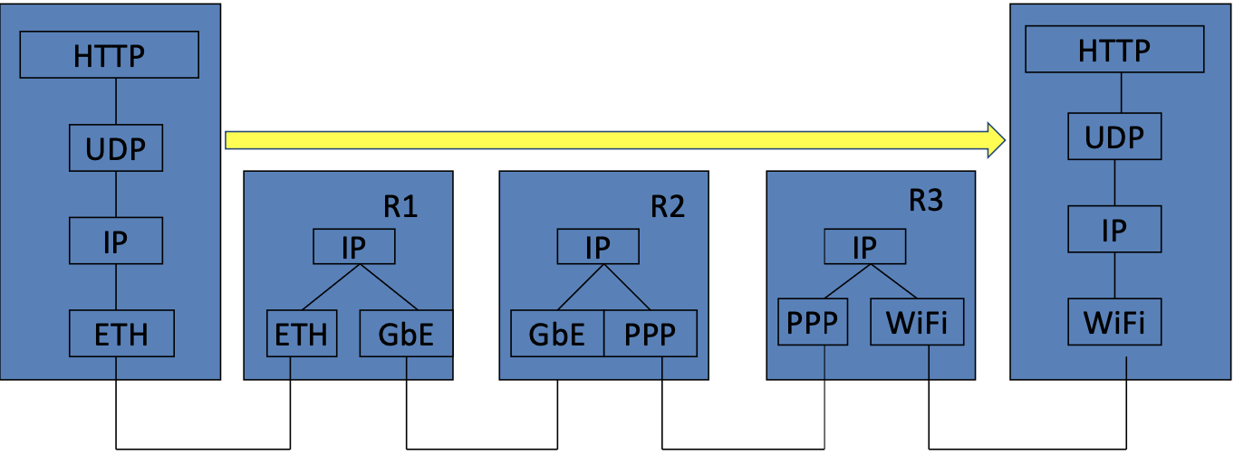

**TCP and UDP are not interoperable**

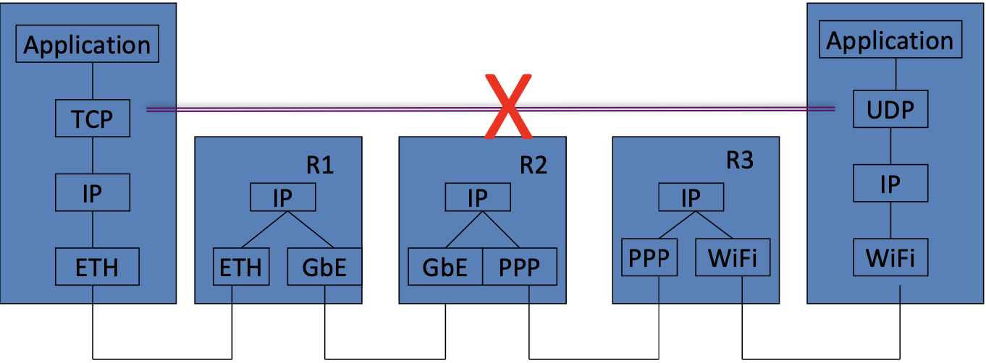

**TCP & UDP Comparison**

|  |  |  |
| --- | --- | --- |
| **Characteristic** | **TCP** | **UDP** |
| General | Full-featured protocol to reliably communicate data with another application across IP. | Simple, high speed, low functionality wrapper that interfaces with IP |
| Connection | Connection-oriented; setup prior to transmission | Connectionless, no setup |
| Interface to Application | Stream based | Discrete message based |
| Reliability and ACK | Reliable, all messages acknowledged | No reliability guaranteed, best effort delivery without acknowledgement |
| Retransmissions | All lost data retransmitted automatically | None. Application must detect if needed |
| Flow control | Flow control on both ends (sliding window) | None |
| Overhead | Low, but not as low as UDP | Low |
| Speed | High, but not as high as UDP | Very high |
| Data quantity | Small to very large (gigabytes) | Single datagram - up to 65K bytes |
| Applicability | Data must be received reliably, in order. | Speed matters more than completeness. Small discrete messages. **Multicast or broadcast** |

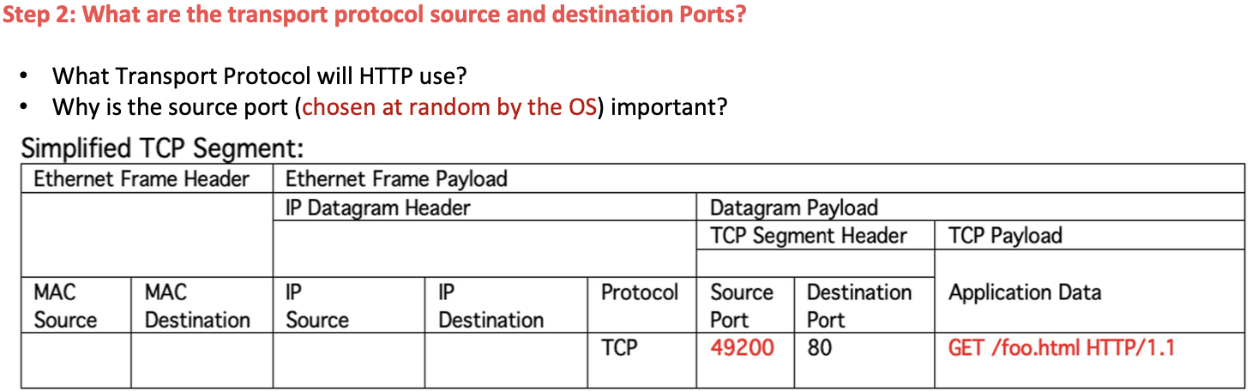





**Internet Protocol (IP) Layer**

* Abstraction: A (nonguaranteed) single datagram of data from any host on the Internet to any other host. Another fire and forget messaging pattern即发即忘

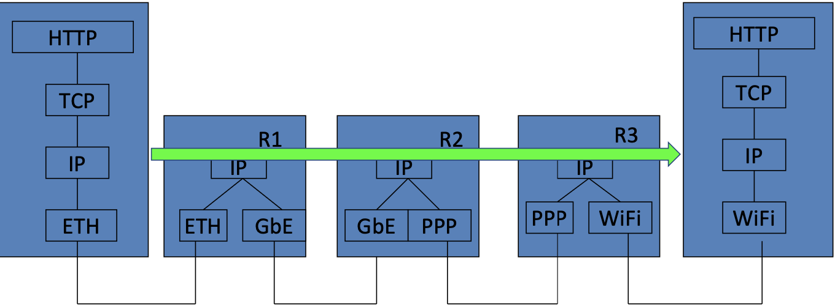

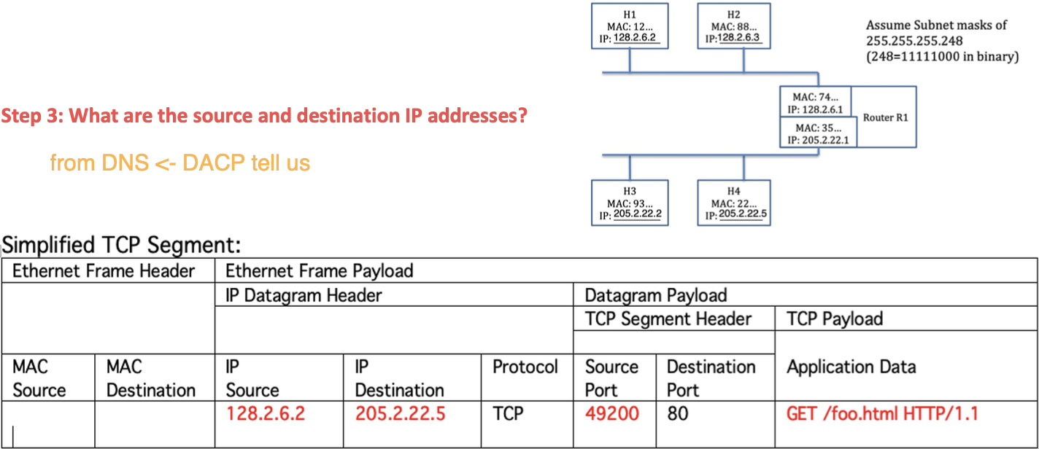



**Data link layer (e.g. Ethernet)**

* Abstraction: A single frame of data from one host on a network to another host **on that same network**  
  This too is fire and forget.

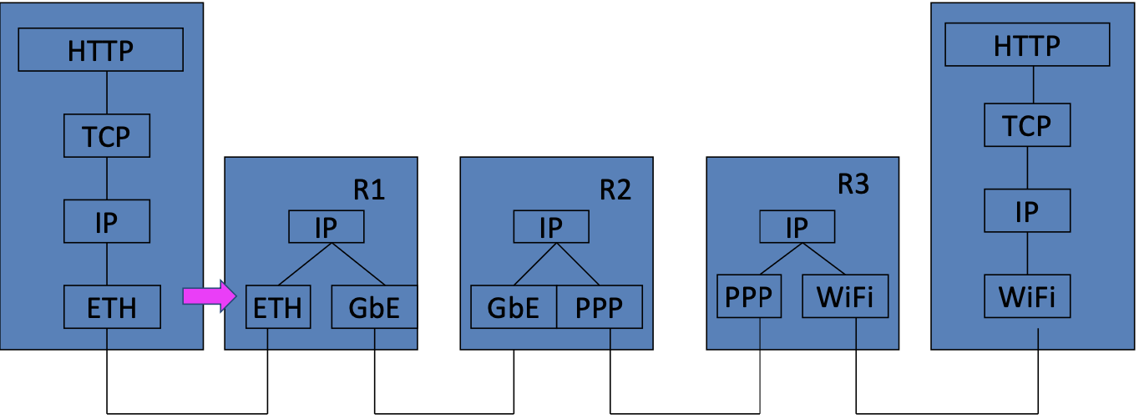

**Data link layer addressing - MAC address**

* Each networking device has a MAC address

– Media Access Control address

* Fixed by manufacturer
* A laptop my have a few:

– Ethernet: 60:fb:42:ff:fe:f8:b5:08, used by Ethernet

– Wi-Fi: 60:fb:42:f8:b5:08, used by Wireless Fidelity (WiFi)

– Bluetooth: 60:fb:42:72:08:4c, Used by Bluetooth

* A smartphone could also have a couple:

– Wifi

– Bluetooth

– And an IMEI number, which is like a mobile MAC

**Address Resolution Protocol (ARP)**

* Host H1 wants to send a message to R1 on the same network. It knows the IP but needs the MAC.
* First, H1 checks its cache to see if it already contains the IP / MAC address pair.

– If it does then use the MAC address.

* If it does not

– H1 broadcasts the IP address to all hosts on this network.

* + Broadcast MAC is FF:FF:FF:FF:FF:FF

– The matching host R1 sends back its MAC address.

– H1 then adds this mapping to its cache.



Because the IP Destination address is on a different network than the IP Source address, the Ethernet Frame cannot be directly addressed to H4. Therefore, the Ethernet Frame must be addressed to a router that will pass the message on to the destination network.

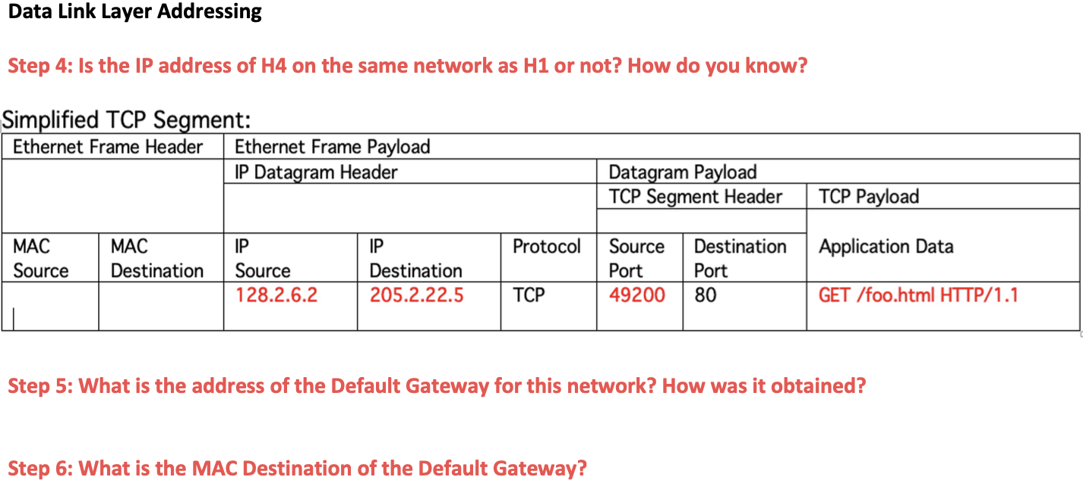

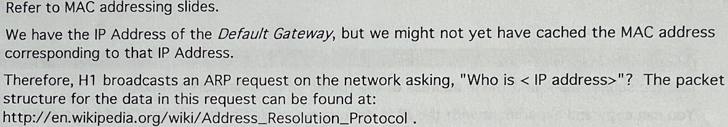

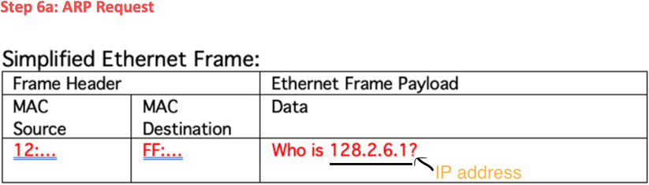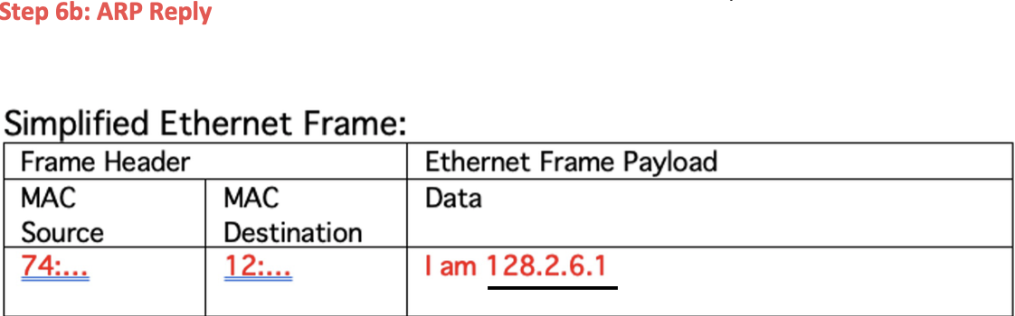

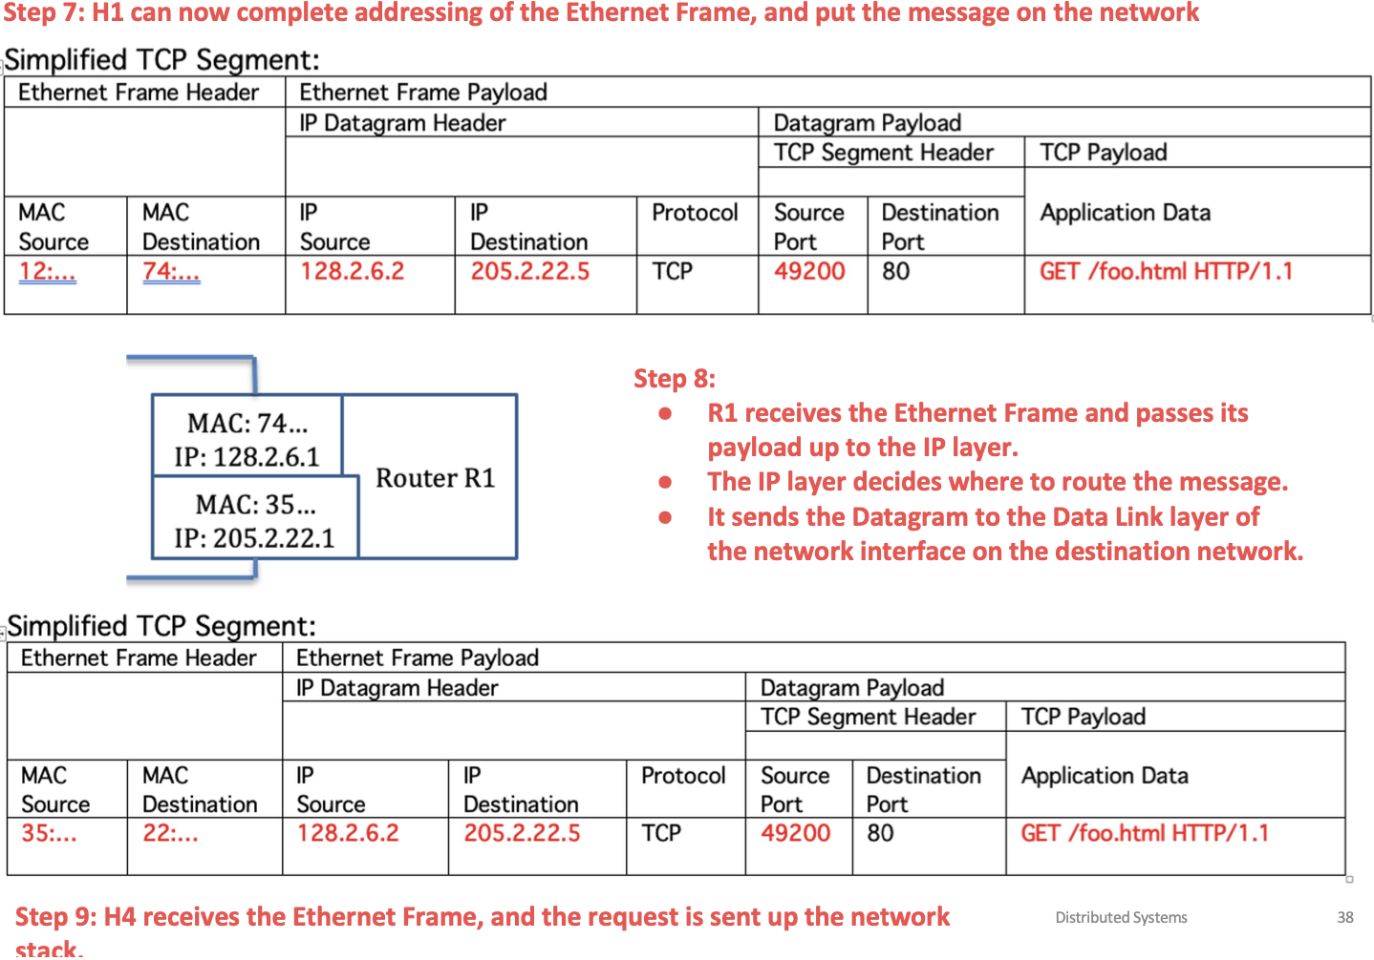

// what is the application that handles the request? – web application

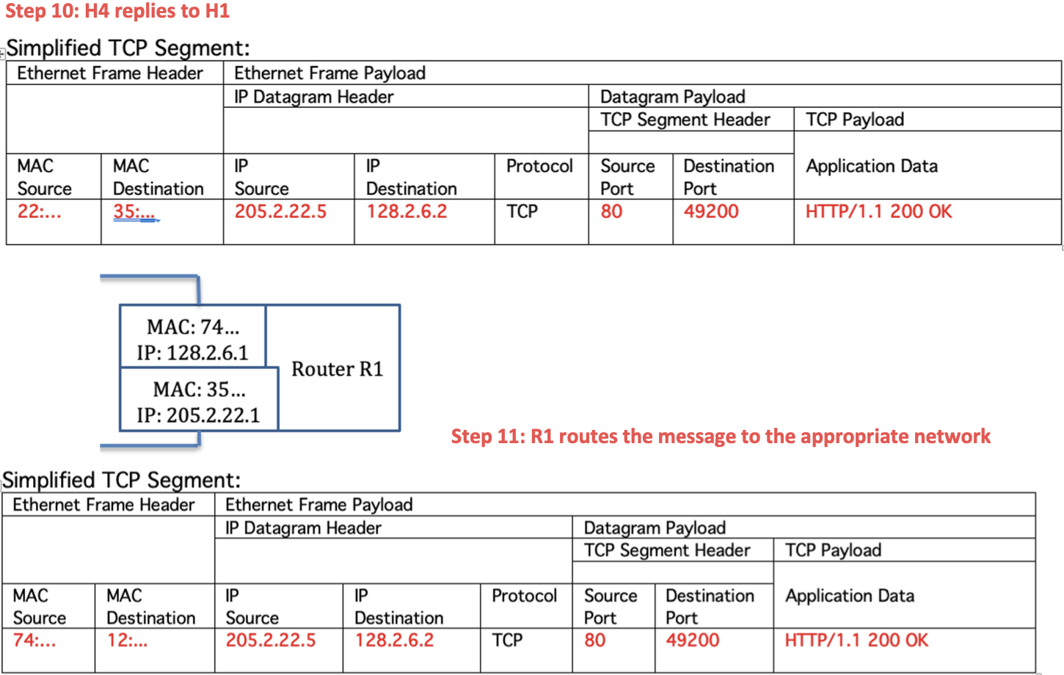

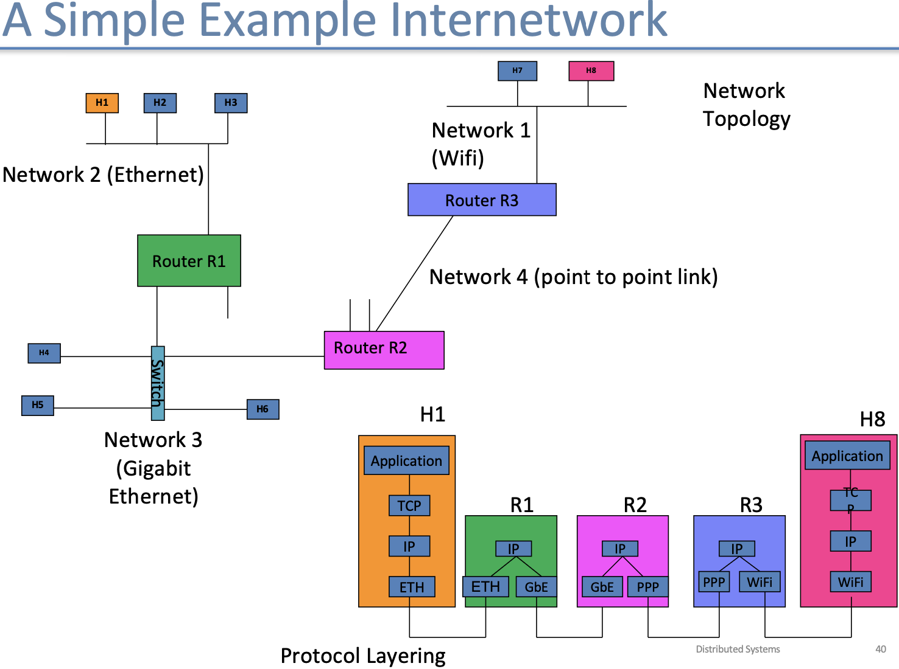

// How does R1 know R2 was the best path from H1 to H8?

algo

**Network vs Internetwork**

* An internetwork is an interconnected collection of networks.
* The Internet Protocol (IP) is the key tool used today to build scalable, heterogeneous internetworks

**Routing in a Wide Area Network**

* Routers maintain routing tables, indicating the best paths to other networks.
* At least every 30 seconds (or earlier when their own table changes) each router will send its routing table to each of its neighbors.
* When receiving a neighbor’s table, a router will update its own tables.

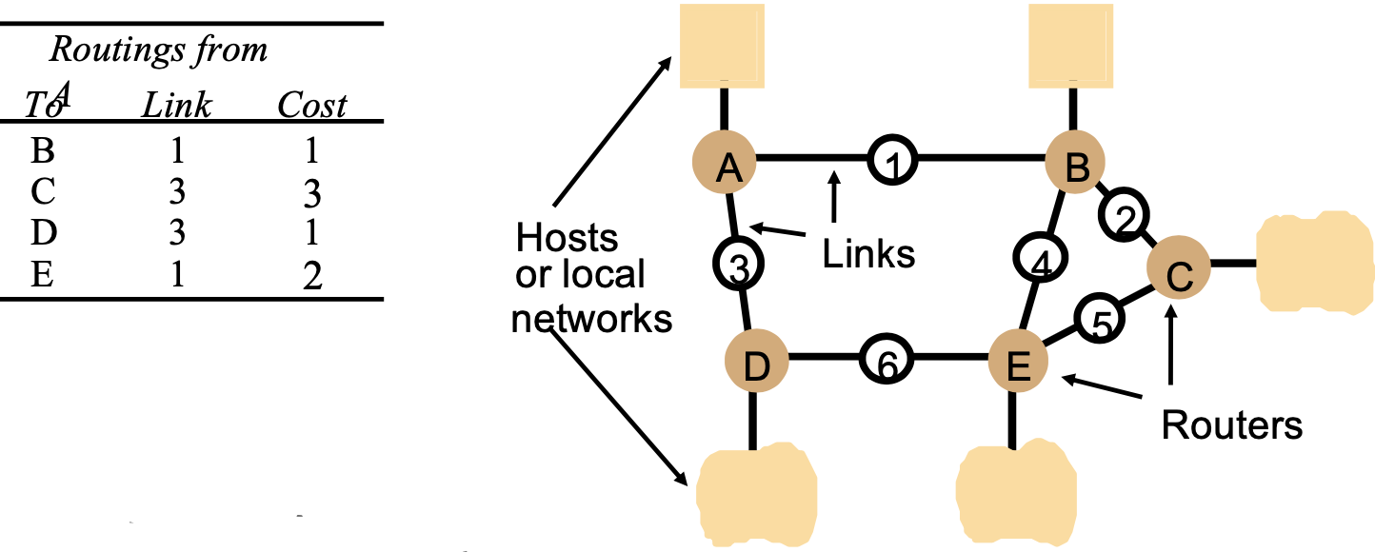

**Update A With info from B | Routing Information Protocol (RIP)**

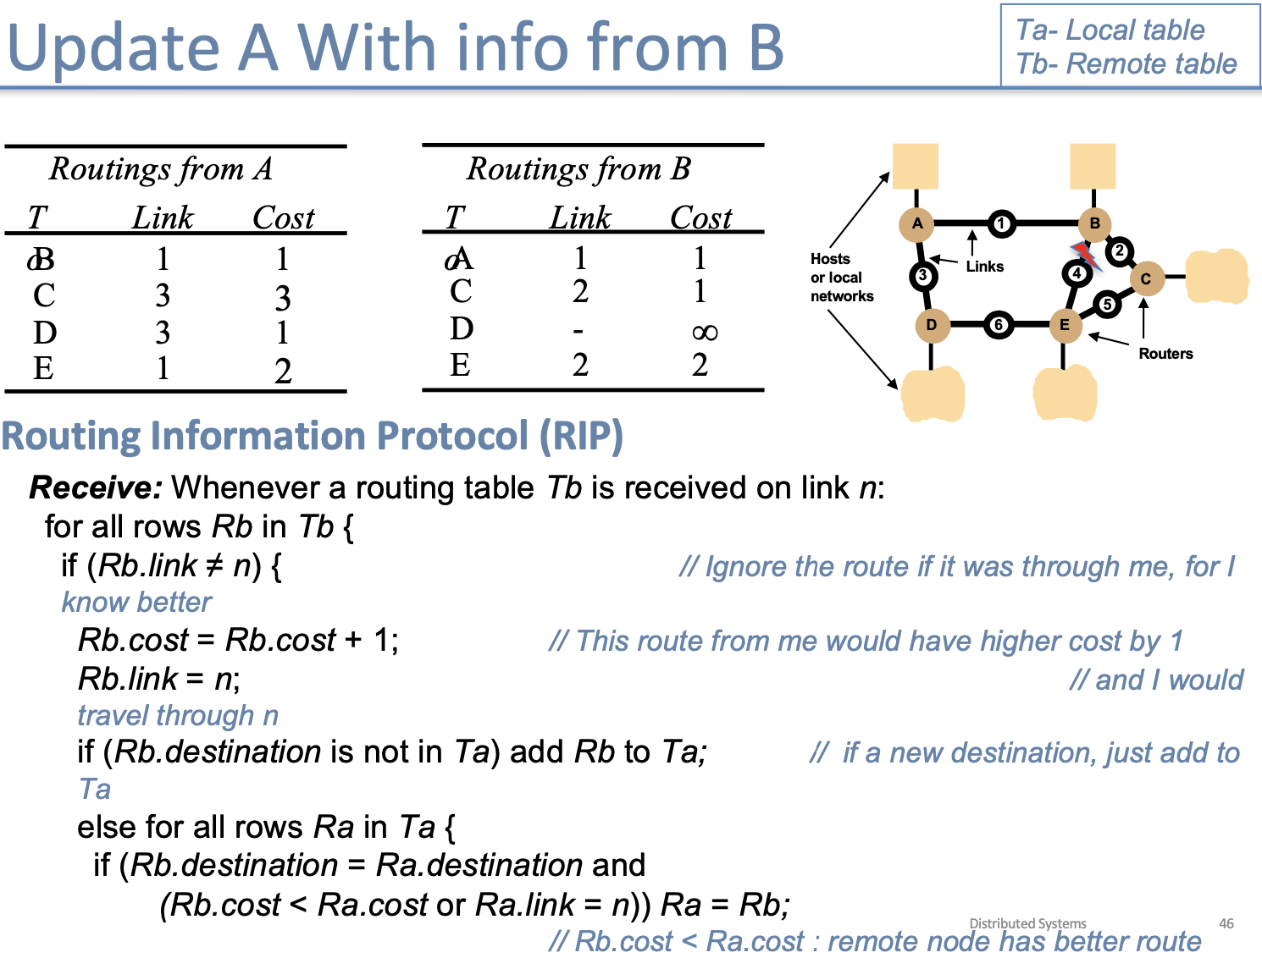

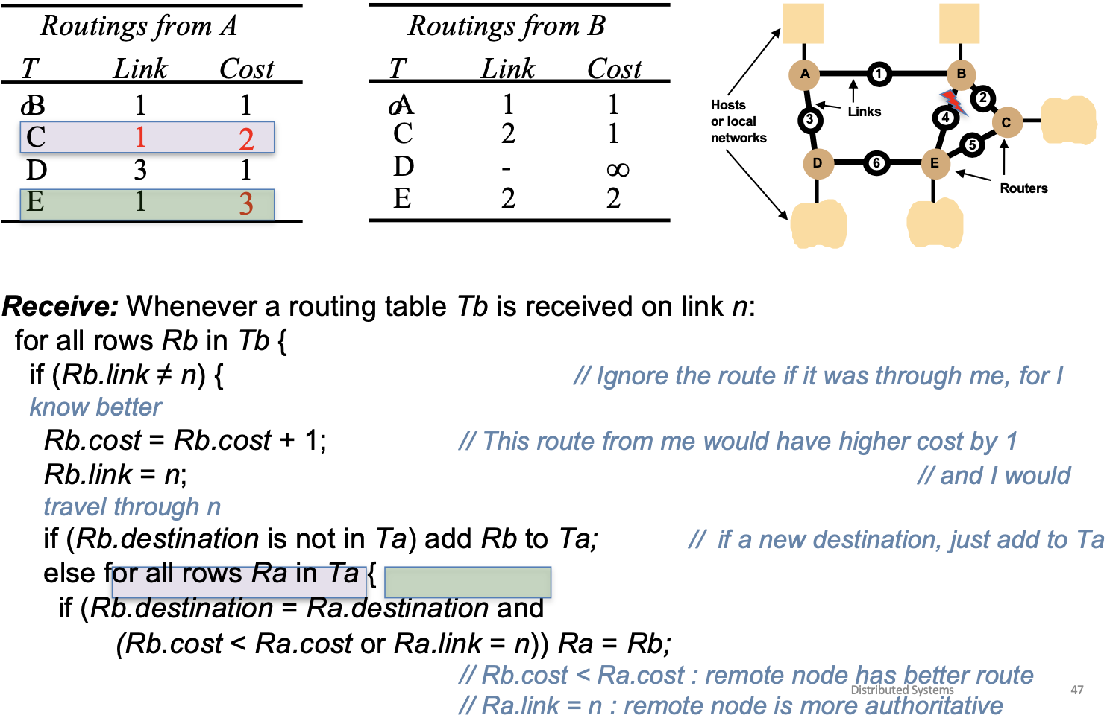

**Types of Routing Algorithms**

1. Interior Gateway Protocols

Interior == Within an ISP or large organization

1. Vector-Distance Algorithms

• RIP is the simplest example

1. Link-State Algorithms

• Distribution and update of a DB at each node

• Representing all or a substantial portion of an enterprises’ network

• Each router has a map of the network, with which to calculate shortest path to each other node

• Collection of shortest paths becomes the routing table

2. Exterior Gateway Protocols

Exterior == Between ISPs or large organizations

– Border Gateway Protocol

– Vector-Distance Algorithm, with the addition of policy information such as “this link is cheaper” or “only use that link as a backup”

**Review**

• Application layer: (Examples?)

– Abstraction: ? get, response

– Addressing: ? URL

• Transport layer: (What two protocols?)

– Abstraction: ? stream TCP, package for UDP

– Addressing: ? IP address + port

• Internet layer:(What primary protocol?) IP

– Abstraction: ? fire and forget, no response

– Addressing: ? IP address , no port

• Data Link Layer: (E.g. Ethernet) wifi

– Abstraction: ? fire and forget

– Addressing: ? MAC address

**Lec 3课前阅读**

物理层

Become familiar with the following Internet Protocols. For each, you should understand its acronym, its full name, its network layer, and its purpose. In terms of its purpose, you should be able to describe it in a single sentence.

1. HTTP超文本传输协议

* Full name: HyperText Transfer Protocol
* Network layer: Application layer
* Purpose: Enables the transfer of web pages from servers to browsers.

1. HTTPS安全超文本传输协议

* Full name: HyperText Transfer Protocol Secure
* Network layer: Application layer
* Purpose: Securely transfers encrypted web pages from servers to browsers.

1. DHCP动态主机配置协议

* Full name: Dynamic Host Configuration Protocol
* Application layer
* Purpose: A server assigns an IP address, a gateway address, and a DNS server address to a host.

1. DNS域名系统

* Full name: Domain Name System
* Network layer: Application layer
* Purpose: Translates domain names to IP addresses.

1. RTP/RTCP实时传输协议/实时控制协议

* Full name: Real-time Transport Protocol/Real-Time Control Protocol
* Network layer: Application layer
* Purpose: RTP is used for delivering media streams, while RTCP monitors and provides feedback on the quality of data distribution.

1. LDAP轻量级目录访问协议

* Full name: Lightweight Directory Access Protocol
* Network layer: Application layer
* Purpose: Provides access to and maintains distributed directory information over an IP network.

1. POP邮局协议

* Full name: Post Office Protocol
* Network layer: Application layer
* Purpose: Retrieves emails from a mail server to a local client.

1. **IMAP**互联网消息访问协议

* Full name: Internet Message Access Protocol
* Network layer: Application layer
* Purpose: Manages and retrieves emails from a mail server, allowing multiple device synchronization.

1. **SMTP**简单邮件传输协议

* Full name: Simple Mail Transfer Protocol
* Network layer: Application layer
* Purpose: Sends outgoing email messages from a client to a server or between servers.

1. **SSH**安全外壳

* Full name: Secure Shell
* Network layer: Application layer
* Purpose: Allows secure remote command-line login and command execution on a remote machine.

1. **UDP**用户数据报协议

* Full name: User Datagram Protocol
* Network layer: Transport layer
* Purpose: Sends data **packets** over the Internet without ensuring delivery or order.

1. **TCP**传输控制协议

* Full name: Transmission Control Protocol
* Network layer: Transport layer
* Purpose: Ensures reliable and ordered delivery of data packets over the Internet.

1. **ARP**地址解析协议

* Full name: Address Resolution Protocol
* Network layer: Link layer
* Purpose: Maps a 32-bit IP address to a **MAC address** within a local network.

**Moving between decimal, hex, and binary number representations**

